# Project Design Phase-I Solution Architecture

|  |  |
| --- | --- |
| Date | 18 October 2022 |
| Team ID | PNT2022TMID43478 |
| Project Name | Personal Assistant for senior people who are self-reliant |
| Maximum Marks | 4 Marks |

**Solution Architecture:**

* Old people who are need pill remainder and self-assistance because they don't want to skip their medicines.
* Create a web application which remind the tablets name and time & Create a smart watch which can be able to ring an alarm and vibrate on time.
* It reminds the medication time through alarm andvibrations.

# Solution Architecture Diagram:

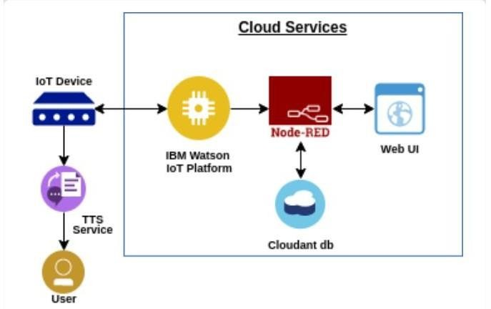

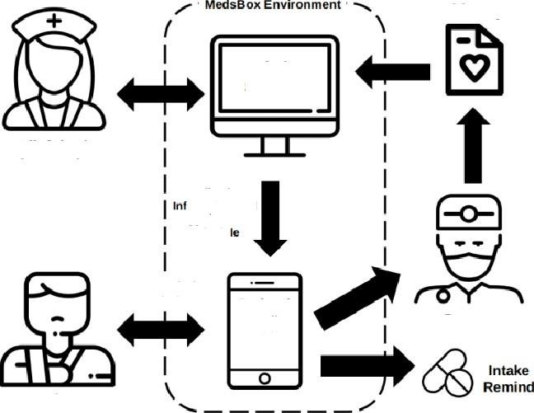

Health Report

Admin

System

Clinician/

Pharmacist

Medication

or mation and

A pp oi nt:ment

Schedu

Set Prescription

RemindgE Patient

Guardian Mobile Phone'

Doctor

Medicine

Patient